Ridge & Lasso Regression:
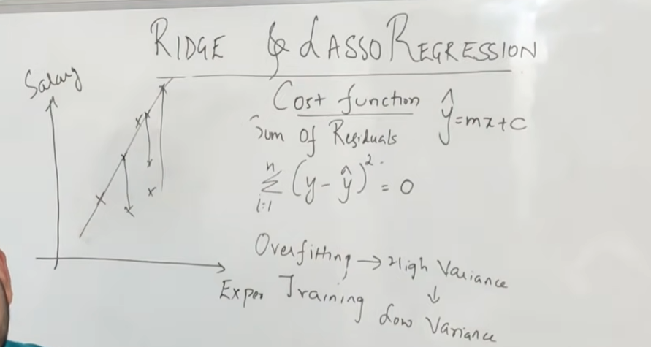
We try to reduce the cost function in linear regression.
But in this we will make it 0.
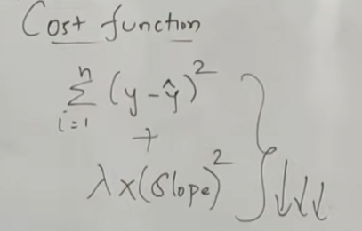
Lambda is assigned from 0 to any +ve number.
We will try to make the slope less steper
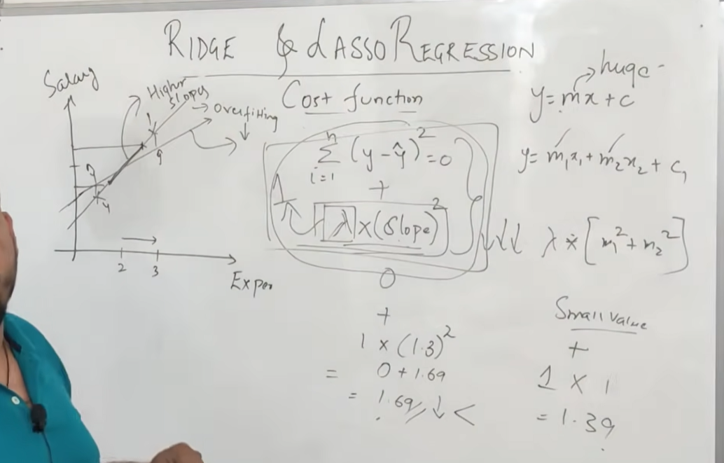
It is used to do feature selection //Lasso regression
